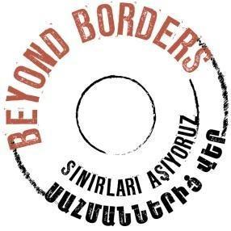
TÜRKİYE-ARMENIA TRAVEL GRANT CONTACT PERSON CONFIRMATION FORM

To Hrant Dink Foundation,

I hereby confirm that I have been informed that my name, surname and contact details have been provided as a contact person in the Türkiye–Armenia Travel Grant application submitted by the [applicant name].
I am aware of the purpose of the applicant’s planned visit and the programme they intend to undertake. During their visit, I would be pleased to meet with the applicant and, where relevant, engage with them regarding the initial steps of their proposed project and the programme they have outlined.
I also agree that the Hrant Dink Foundation will contact me in relation to this Travel Grant application.
This confirmation does not imply any financial, legal, accommodation, or other personal responsibility for the applicant or their travel.
Name Surname,
Signature

